Local dns: 165.87.13.129 (AT&T (US))

Google’s public dns: 8.8.8.8

|  |  |  |  |
| --- | --- | --- | --- |
| Website | my_dns | Local dns | Google’s public DNS |
| Google.com | 288.5 | 9 | 13.2 |
| Youtube.com | 282 | 9.1 | 14.5 |
| Facebook.com | 293.3 | 8.3 | 1.3 |
| Baidu.com | 489 | 9.2 | 1.4 |
| Wikipedia.org | 315.1 | 8.4 | 29 |
| Yahoo.com | 310 | 9 | 2.3 |
| qq.com | 527 | 11.5 | 1.2 |
| Taobao.com | 412.4 | 77.2 | 52 |
| Tmall.com | 369.7 | 74 | 50.9 |
| Twitter.com | 276 | 9.1 | 1 |
| Google.co.in | 584.2 | 9 | 14 |
| Amazon.com | 281 | 8 | 12 |
| Instagram.com | 296 | 8.3 | 2.6 |
| Vk.com | 784 | 9.2 | 1.2 |
| Reddit.com | 290.2 | 8.8 | 2 |
| Sohu.com | 539 | 8 | 219 |
| Live.com | 363.3 | 9.2 | 42 |
| Jd.com | 600.2 | 8.4 | 235.4 |
| Yandex.ru | 472.4 | 8.3 | 1.2 |
| Weibo.com | 530.3 | 8 | 224.6 |
| Sina.com | 512.1 | 9 | 216.7 |
| Google.co.jp | 701 | 9.1 | 14.6 |
| 360.cn | 998.2 | 60.8 | 220.1 |
| Login.tmall.com | 1003 | 49.1 | 199 |
| Blogspot.com | 313.2 | 8.7 | 14.2 |

Following is the CDF of the above mentioned data:

We have:

Record on X axis

Time in millisecond on Y axis

Time in (ms) [y axis]

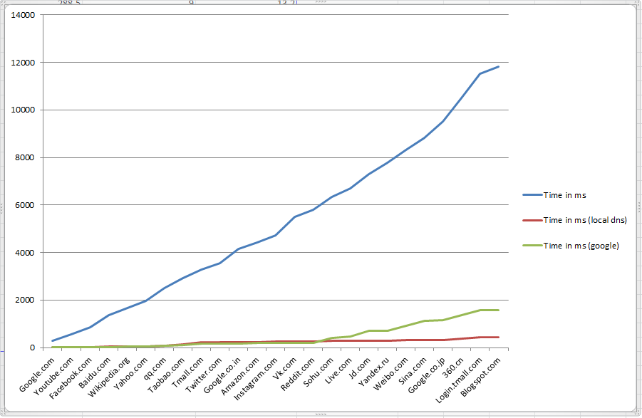

Record number[x axis]